







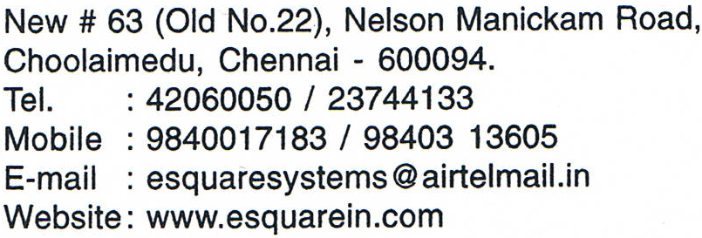

**New #63(Old No.22.),Nelson Manickam Road,**

**Choolaimedu,Chennai – 600 094.**

**Tel. :044-42060050 / 23744133**

**Mobile :09840017183 / 9841828292**

**E-Mail :** [**esquaresys@gmail.com**](mailto:esquaresys@gmail.com)

**Website: www.esquarein.com**